MOCK SCREENS FOR MATING DESIGNS:

Menu:

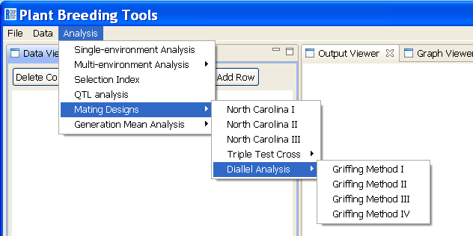

North Carolina I
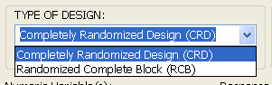
Required fields:
If CRD, Female, Male and Replicate are enabled.
If RCB, Female, Male and Replicate are enabled.
NOTE: Environment is always enabled.

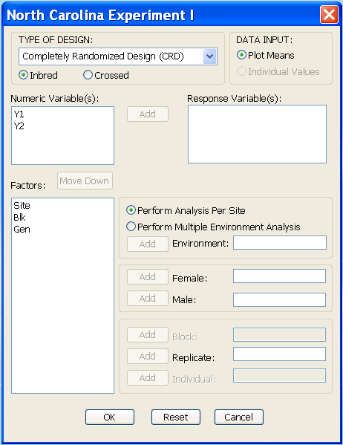
For now, this is disabled always
For now, this is disabled always
Allow multiple selection;
if user select item(s) here, only response variable’s Add button and Move Down button are enabled.
single selection; if user select item here, Add buttons of the EMPTY required fields are enabled;
if the selected item is previously in the numeric variables list, Move Down button will be enabled but the label will be “Move Up”;

Allow multiple selection;
If user selects item(s) here, Add button will be enabled but the label will be “Remove”;
If user selects item here, Add button will be enabled but the label will be “Remove”;
When the user clicks OK, check if all required fields are not empty;
If Perform Multiple Environment Analysis is selected, check if the variable entered in Environment has more than one level/unique value;
If Perform Analysis Per Site is selected, Environment field can be empty or not;

North Carolina II (same requirements as in NCI)

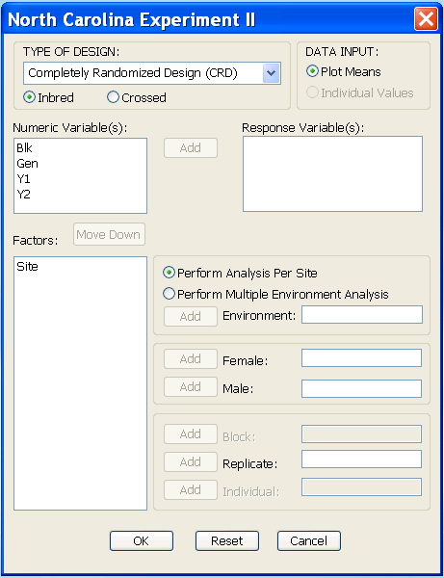

North Carolina III (same requirements as in NCI)
Required fields:
If CRD, Tester, F2 and Replicate are enabled.
If RCB, Tester, F2 and Replicate are enabled.
NOTE: Environment is always enabled.

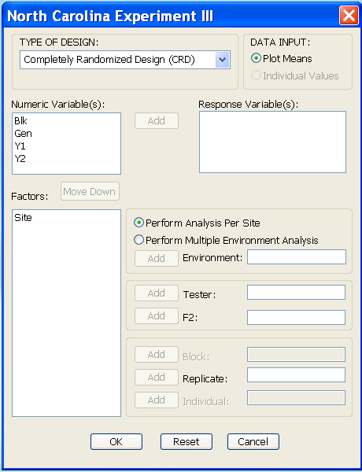

Required fields:
If CRD, Tester, F2 and Replicate are enabled.
If RCB, Tester, F2 and Replicate are enabled.
NOTE: Environment is always enabled.

Triple Test Cross (same requirements as in NCI)
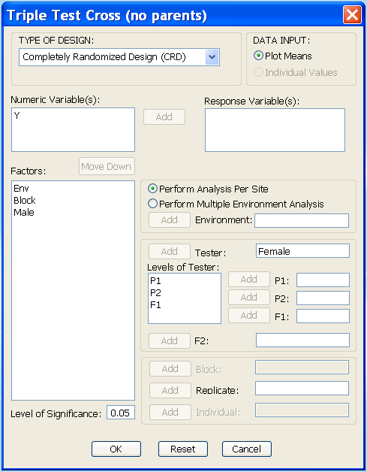
If user selects item here, Add button will be enabled but the label will be “Remove”;
If Tester is empty, Levels of Tester field, Add buttons and fields of P1, P2 and F1 are disabled;
If Tester is NOT empty, Levels of Tester field should display the different levels/unique values of the variable in the Tester;

The value of this should be numeric from 0 to 1 only.
Default value is 0.05

Diallel Analysis – Griffing Method I (same requirements as in NCI)
Required fields:
If CRD, P1, P2 and Replicate are enabled.
If RCB, P1, P2 and Replicate are enabled.
NOTE: Environment is always enabled.
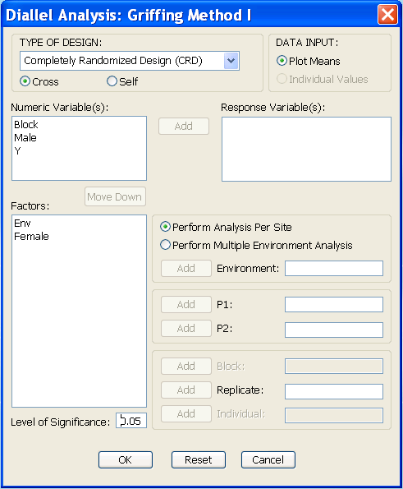

The value of this should be numeric from 0 to 1 only.
Default value is 0.05

Diallel Analysis – Griffing Method II (same requirements as in Diallel I)

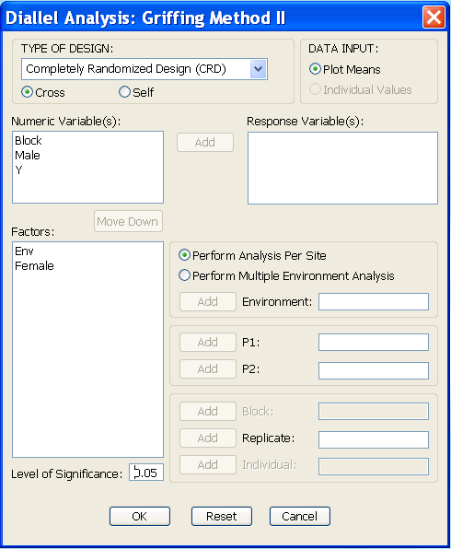

Diallel Analysis – Griffing Method III (same requirements as in Diallel I)
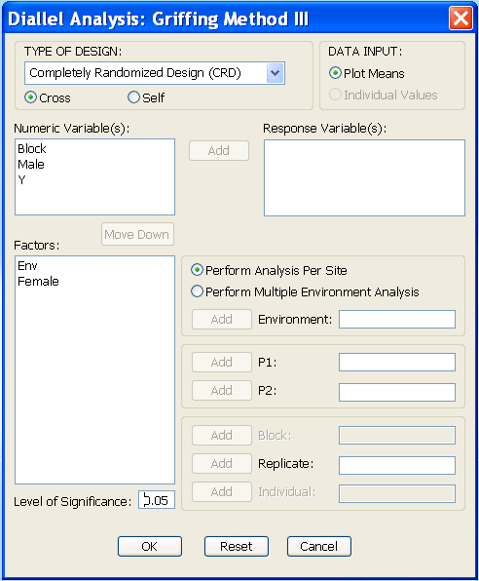

Diallel Analysis – Griffing Method IV (same requirements as in Diallel I)

